**MACHINE LEARNING  
  
  
 PROJECT 1 - ADMISSION PREDICTION**

**GROUP-22**

Rohit Bairwa - Nowrosjee Wadia College

Aditya Kadagala - TKRCET

Prashant Kumar - Atria Institute of Technology

Prajwal Mahanawar – PVG’S COET

MENTOR : PRANAV JAIPURKAR



  


**ABSTRACT**

Graduation rates for institutions are an increasingly important metric to an incoming student and for ranking universities. With the increase in the number of graduates who wish to pursue their education, it becomes more challenging to get admission to the students' dream university. Using this predictive modeling, incoming students can be assessed as to their likelihood of completing a degree. This project addresses machine learning models to predict the chance of a student to be admitted to a master's program thus the machine learning approach is developed to automatically predict the possibility of postgraduate admission to help graduates recognizing and targeting the universities which are best suitable for their profile. This will assist students to know in advance if they have a chance to get accepted. This project evaluates based on four strategic models to predict the university rate given the students' profile. The predicting models involved are multiple linear regression, random forest regression, multiple linear regression with PCA and random forest regression with PCA. This project evaluates based on the models to select the best model in terms of the highest accuracy rate and the least error.

**TABLE OF CONTENTS**

1. Introduction

1.1 Machine Learning

1.2 Machine Learning Methods

1.3 Machine Learning Algorithm

2. Machine Learning Models

2.1 Multiple Linear Regression

2.1.1 Description

2.1.2 Implementation of Linear Regression

2.1.3 Applications

2.2 Multiple Linear Regression with PCA

2.2.1 Description

2.2.2 Implementation of Linear Regression using PCA

2.2.3 Applications

2.3 Random Forest Regression

2.3.1 Description

2.3.2 Implementation of Random Forest Regression

2.3.3 Applications

2.4 Random Forest Regression with PCA

2.4.1 Description

2.4.2 Implementation of Random Forest Regression using PCA

2.4.3 Applications

3. Software-libraries

4. Conclusion

1.Introduction

**1.1 Machine Learning:**

Machine Learning is a subset of Artificial Intelligence which is typically used so that the machine (computer) can process the input and keep learning on its own self so as to improve the decisions it should take to generate a better output without having much human intervention.

The machine learns through the data provided typically datasets by finding patterns in the data using statistics. The process of learning begins with observations or data, such as examples, direct experience, or instruction, in order to look for patterns in data and make better decisions in the future based on the examples that we provide.

Machine Learning in its application across business problems, is also referred to as predictive analytics.

**Difference between Traditional Programming and Machine LearningImage**

**1.2 Types of Machine Learning:**

There are 3 broad types of Machine Learning Algorithms. They are:

Supervised machine learning algorithms: Using these algorithms, the machine tries to analyse the provided datasets for patterns, correlation and predicts the output.

Classification and Regression are some of the supervised machine learning algorithms.

Unsupervised machine learning algorithms: It is more of a grouping algorithm that groups the dataset consisting of unlabelled and unstructured data by finding patterns within the data.

Clustering is an unsupervised Machine Learning algorithm.

Reinforcement machine learning: This involves the machine to improve its performance by analysing repeated or multiple test cases. Trial and error search and delayed reward are the most relevant characteristics of reinforcement learning. This method allows machines and software agents to automatically determine the ideal behaviour within a specific context in order to maximize its performance.

**1.3 Steps involved in Machine Learning:**

Gathering past data in any form suitable for processing.

The better the quality of data, the more suitable it will be for modeling. Data Processing – Sometimes, the data collected is in the raw form and it needs to be pre-processed. Example: Some tuples may have missing values for certain attributes, an, in this case, it has to be filled with suitable values in order to perform machine learning or any form of data mining.

Missing values for numerical attributes such as the price of the house may be replaced with the mean value of the attribute whereas missing values for categorical attributes may be replaced with the attribute with the highest mode. This invariably depends on the types of filters we use. If data is in the form of text or images then converting it to numerical form will be required, be it a list or array or matrix. Simply, Data is to be made relevant and consistent. It is to be converted into a format understandable by the machine.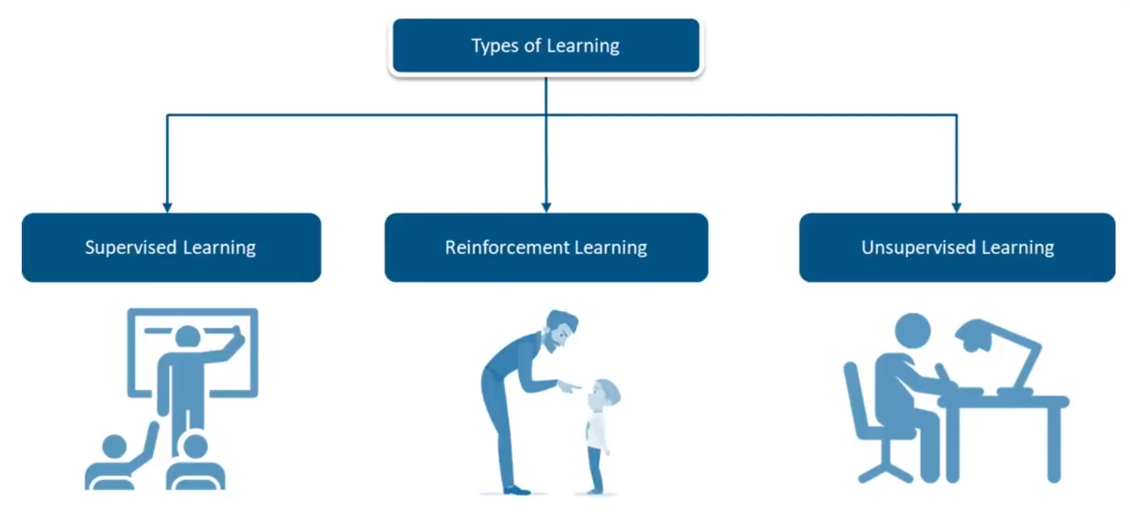

Divide the input data into training,cross-validation and test sets. The ratio between the respective sets must be 6:2:2.

Building models with suitable algorithms and techniques on the training set.

Testing our conceptualized model with data which was not fed to the model at the time of training and evaluating its performance using metrics such as F1 score, precision and recall.

**Types of Learning**

The dataset given to a ML model is split into:

**Training Data:** The part of data we use to train our model. This is the data which your model actually sees(both input and output) and learn from.

**Validation Data:** The part of data which is used to do a frequent evaluation of model, fit on training dataset along with improving involved hyperparameters (initially set parameters before the model begins learning). This data plays it’s part when the model is actually training.

**Testing Data:** Once our model is completely trained, testing data provides the unbiased evaluation. When we feed in the inputs of Testing data, our model will predict some values(without seeing actual output). After prediction, we evaluate our model by comparing it with actual output present in the testing data. This is how we evaluate and see how much our model has learned from the experiences feed in as training data, set at the time of training.

**1.4 Applications:**

Machine learning is important because it gives enterprises a view of trends in customer behavior and business operational patterns, as well as supports the development of new products. Many of today's leading companies, such as Facebook, Google and Uber, make machine learning a central part of their operations. Machine learning has become a significant competitive differentiator for many companies.

Some of the common use cases are: Web Search Engine, Photo tagging Applications, Spam Detector, Database Mining for growth of automation, Applications that cannot be programmes

**2. MACHINE LEARNING MODELS**

**SIMPLE LINEAR REGRESSION**

**AND MULTIPLE LINEAR**

**REGRESSION**

**WHAT IS LINEAR REGRESSION ?**

* Linear Regression is a supervised machine learning algorithm wherethe predicted output is continuous and has a constant slope.
* It’s used to predict values within a continuous range, (e.g. sales, price)rather than trying to classify them into categories (e.g. cat, dog).
* **There are 2 types of Linear regression model:**
* Simple Linear Regression
* Multiple Linear Regression

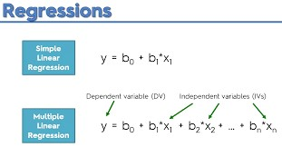

# SIMPLE LINEAR REGRESSION

* Simple linear regression uses traditional slope-intercept form,where a and b are the variables our algorithm will try to “learn” to are the variables our algorithm will try to “learn” to produce the most accurate predictions.
* x represents our input data.
* y represents our prediction.
* Formula: y = a x +b

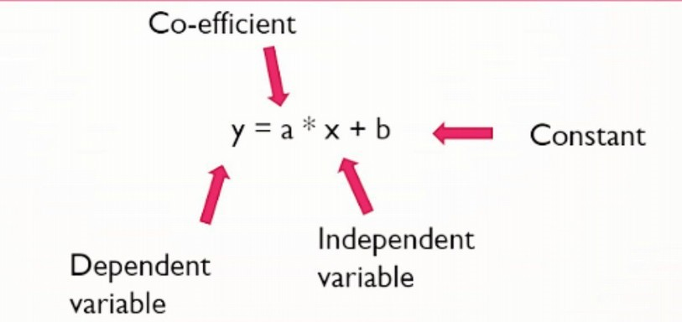

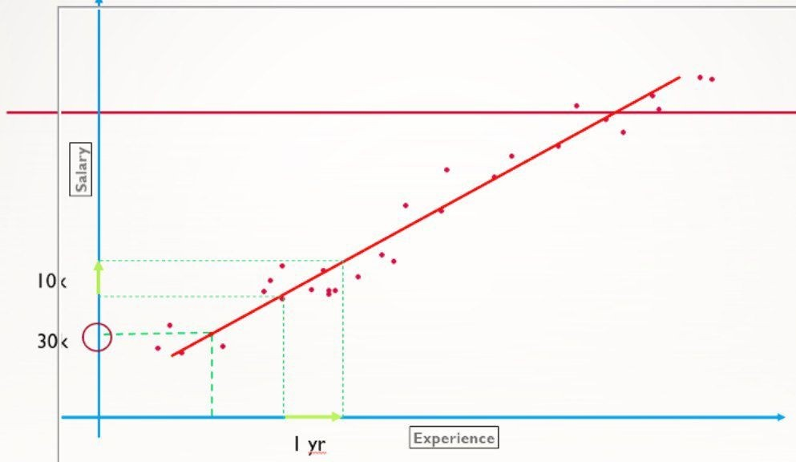

**MULTIPLE LINEAR REGRESSION**

A more complex, multi-variable linear equation might look like this, where represents the coefficients, or weights, our model will try to learn.

* 𝑓(𝑥,𝑦,𝑧) = (𝑤 ( ) = 1*𝑥 ( )+ 2*𝑦 ( )+ 3𝑧) = (𝑤) ) = (𝑤 ( ) = 1*𝑥 ( )+ 2*𝑦 ( )+ 3𝑧) = (𝑤) ( ) = 1*𝑥 ( )+ 2*𝑦 ( )+ 3𝑧) = (𝑤 ( ) = 1*𝑥 ( )+ 2*𝑦 ( )+ 3𝑧) = (𝑤) ) = (𝑤 ( ) = 1*𝑥 ( )+ 2*𝑦 ( )+ 3𝑧) = (𝑤) )
* The variables represent the attributes, or distinct pieces of information, 𝑥,𝑦,𝑧) = (𝑤 ( ) = 1*𝑥 ( )+ 2*𝑦 ( )+ 3𝑧) = (𝑤) ) = (𝑤 ( ) = 1*𝑥 ( )+ 2*𝑦 ( )+ 3𝑧) = (𝑤) we have about each observation.
* For sales predictions, these attributes might include a company’s advertising spend on radio, TV, and newspapers.
* 𝑆𝑎𝑙𝑒𝑠 = (1*𝑅𝑎𝑑𝑖𝑜)+(𝑤 ( )+ 2*𝑇𝑉)+(𝑤 ( )+ 3*𝑁𝑒𝑠 ) = (1*𝑅𝑎𝑑𝑖𝑜)+(𝑤 ( )+ 2*𝑇𝑉)+(𝑤 ( )+ 3*𝑁𝑒𝑠 ) (𝑤 ( ) = 1*𝑥 ( )+ 2*𝑦 ( )+ 3𝑧) = (𝑤) )+ ( )+ 2*𝑇𝑉)+(𝑤 ( )+ 3*𝑁𝑒𝑠 ) (𝑤 ( ) = 1*𝑥 ( )+ 2*𝑦 ( )+ 3𝑧) = (𝑤) )+ ( )+ 3*𝑁𝑒𝑠 = (1*𝑅𝑎𝑑𝑖𝑜)+(𝑤 ( )+ 2*𝑇𝑉)+(𝑤 ( )+ 3*𝑁𝑒𝑠 ) )
* **There are 5 methods to build the model:**

1. All-in
2. Backward Elimination
3. Forward Selection
4. Bi-directional Elimination
5. Score Comparison

**ALL-IN METHOD**

* + You have no prior knowledge
  + Preparing for backward elimination

**FORWARD SELECTION METHOD**

1.Select a Signinficance level to enter the model.

2.Fit all the regression model y~xn.Select the one with the lowest p-value

3.Keep this variable and fit all posible model with one extra pridictor added to the ones you already have.

4.Consider the predictor with the lowest P-Value.If P-value. If P<SL ,go to STEP 3,otherwise FINISH.

**BACKWARD ELIMINATION METHOD**

1. Select a significance level to stay in the model ( e.g. SL = 0.05) rt
2. Fit the full model with all possible predictors
3. Consider the predictor with the highest P-value. If P > SL , go to step 4 otherwise Finish.
4. Remove the predictor
5. Fit the model without the variable

**BIDIRECTIONAL ELIMINATION**

* + Select a significance level to enter and to stay in the model. ( e.g. SLENTER =

0.05, SLSTAY = 0.05)

* + Perform the next step of the Forward Selection (new variable must have: P < SLENTER to enter)
  + Perform all the steps of Backward Elimination method (old variable must have P < SLSTAY to stay)
  + No new variables can enter and no old variable can exit. • Finish your model

**COST FUNCTION:**

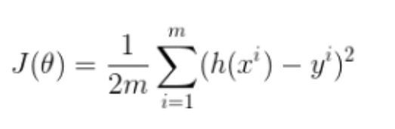

**HYPOTHESIS FUNCTION:**

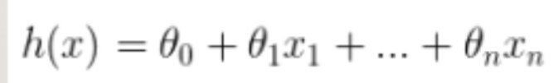

**GRADIENT DESCENT**

* + Gradient descent is a generic optimization algorithm used in many machine learningalgorithms.
  + It iteratively tweaks the parameters of the model in order to minimize the cost function.

**STEPS IN GRADIENT DESCENT**

* + We first initialize the model parameters with some random values. This is also called as random initialization. • Now we need to measure how the cost function changes with change in it’s parameters. Therefore we compute the partial derivatives

of the cost function w.r.t to the parameters θ ,θ , … ,θ₀,θ₁, … ,θ ₁, … ,θ

**LEARNING RATE**

* + 𝛼 is the learning rate. is the learning rate.
  + If the value of α is too small, the cost function takes larger time to converge. When the learning rate is very slow, the gradient descent takes larger time to find the best fit line.
  + If α is too large, gradient descent may overshoot the minimum and may finally fail to converge.

**ALL POSSIBLE MODEL**

* + Select a criterion of goodness of fit (e.g. Akaike criterion) • Construct All Possible Regression Model total Combination.
  + Select the one with the best criterion.
  + Finalize your model.

**HOW DO WE DETERMINE THE BEST FIT LINE ?**

* + The line for which the the error between the predicted values and the observed values is minimum is called the best fit line or the regression line.
  + These errors are also called as residuals.
  + The residuals can be visualized by the vertical lines from the observed data value to the regression line.

**WHAT ARE THE BEST PARAMETERS TO EVALUATE PERFORMANCE OF LINEAR REGRESSION MODEL ?**

* + We will be using Root mean squared error(RMSE) and Coefficient of Determination(R² score) to evaluate our model.
  + RMSE is the square root of the average of the sum of the squares of residuals. • R² score or the coefficient of determination explains how much the total variance of the dependent variable can be reduced by using the least square regression.
  + SS is the total sum of errors if we take the mean of the observed values as the ₜ is the total sum of errors if we take the mean of the observed values as the predicted value.
  + SSᵣ is the sum of the square of residuals.
  + **RMSE FORMULA**

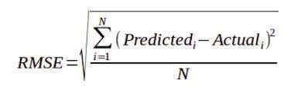

* + **R² SCORE FORMULA**

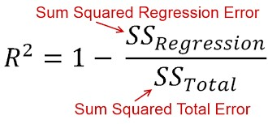

* + **SUM OF SQUARES**

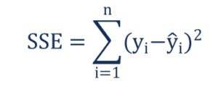

* + **SUM OF RESIDUALS**

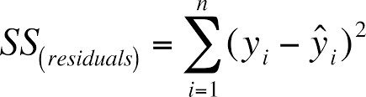

**ASSUMPTIONS**

* + **Linearity:** The relationship between X and the mean of Y is linear.
  + **Homoscedasticity:** The variance of residual is the same for any value of X.
  + **Independence:** Observations are independent of each other.
  + **Normality:** For any fixed value of X, Y is normally distributed.

**ADVANTAGES**

* + Simple Implementation
  + Highly interpretable
  + Scientifically acceptable
  + Widespread availability
  + Performance on linearly seperable datasets
  + Overfitting can be reduced by regularization

**DISADVANTAGES**

* + Prone to underfitting
  + Sensitive to outliers
  + Linear regression also looks at a relationship between the mean of the dependent variables and the independent variables. Just as the mean is not a complete description of a single variable, linear regression is not a complete description of relationships among variables.

**Application Of Linear Regression**

* + It is a very powerful technique and can be used to understand the factors that influence profitability.
  + It can be used to forecast sales in the coming months by analyzing the sales data for previous months.
  + It can also be used to gain various insights about customer behaviour.

**Random Forest Regression**

Random Forest Regression is a supervised learning algorithm that uses ensemble learning method for regression. Ensemble learning method is a technique that combines predictions from multiple machine learning algorithms to make a more accurate prediction than a single model.

Random forest is a bagging technique and not a boosting technique. The trees in randomforests are run in parallel. There is no interaction between these trees while building the trees.

It operates by constructing a multitude of decision trees at training time and outputting the class that is the mode of the classes (classification) or mean prediction (regression) of the individual trees.

A random forest is a meta-estimator (i.e., it combines the result of multiple predictions) which aggregates many decision trees, with some helpful modifications:

1. The number of features that can be split on at each node is limited to some percentage of the total (which is known as the hyperparameter). This ensures that the ensemble model does not rely too heavily on any individual feature, and makes fair use of all potentially predictive features.
2. Each tree draws a random sample from the original data set when generating its splits, adding a further element of randomness that prevents overfitting.

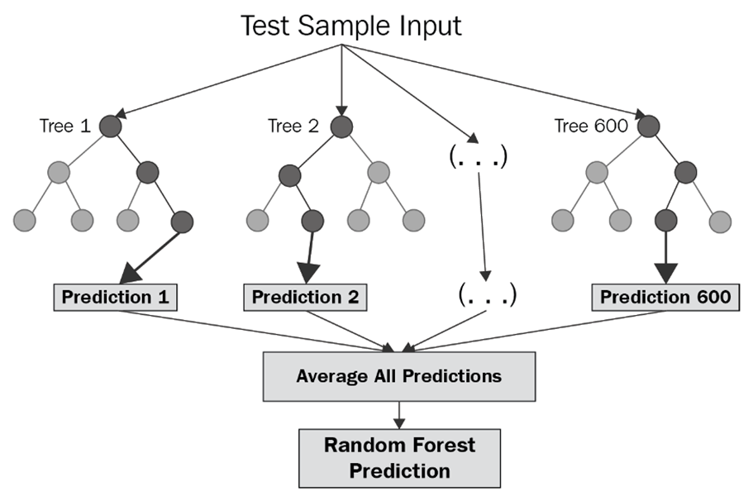

**Ensemble Learning**

An Ensemble method is a technique that combines the predictions from multiple machinelearning algorithms together to make more accurate predictions than any individual model. A model comprised of many models is called an Ensemble model.

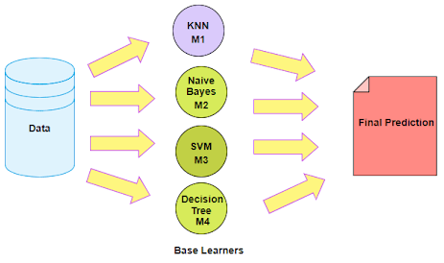

Types of Ensemble Learning:

1. Boosting.
2. Bootstrap Aggregation (Bagging).

1. **Boosting**

Boosting refers to a group of algorithms that utilize weighted averages to make weak learners into stronger learners. Boosting is all about “teamwork”. Each model that runs, dictates what features the next model will focus on.

In boosting as the name suggests, one is learning from other which in turn boosts the learning.

2. **Bootstrap Aggregation (Bagging)**

Bootstrap refers to random sampling with replacement. Bootstrap allows us to better understand the bias and the variance with the dataset. Bootstrap involves random sampling of small subset of data from the dataset.

It is a general procedure that can be used to reduce the variance for those algorithmsthat have high variance, typically decision trees. Bagging makes each model run independently and then aggregates the outputs at the end without preference to any model.

**Feature and Advantages of Random Forest:**

1. It is one of the most accurate learning algorithms available. For many data sets, it produces a highly accurate classifier.
2. It runs efficiently on large databases.
3. It can handle thousands of input variables without variable deletion.
4. It gives estimates of what variables that are important in the classification.
5. It generates an internal unbiased estimate of the generalization error as the forest building progresses.
6. It has an effective method for estimating missing data and maintains accuracy when a large proportion of the data are missing.

**Disadvantages of Random Forest:**

1. Random forests have been observed tooverfit for some datasets with noisy classification/regression tasks.
2. For data including categorical variables with different number of levels**,**random forests are biased in favour of those attributes with more levels. Therefore, the variable importance scores from random forest are not reliable for this type of data.

Implementation of Random Forest Regression using a dataset:

1. Importing Python Libraries and Loading our Dataset into a Data Frame

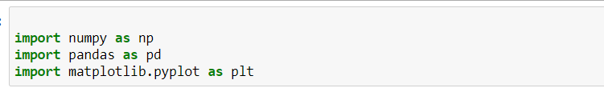

2. Importing the dataset and printing

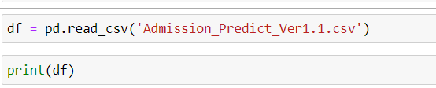

3. Splitting our dataset into training set and test set

(It’s just for illustration purpose. There is no need to split the dataset over here since we only have 10 values in it)



4. Creating a Random Forest Regression model and fitting it to the training data

For this model I’ve chosen 10 trees (n_estimator=10)

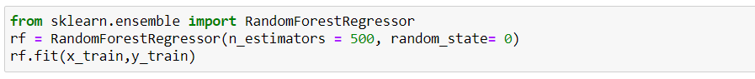

5. Visualizing the Random Forest Regression results

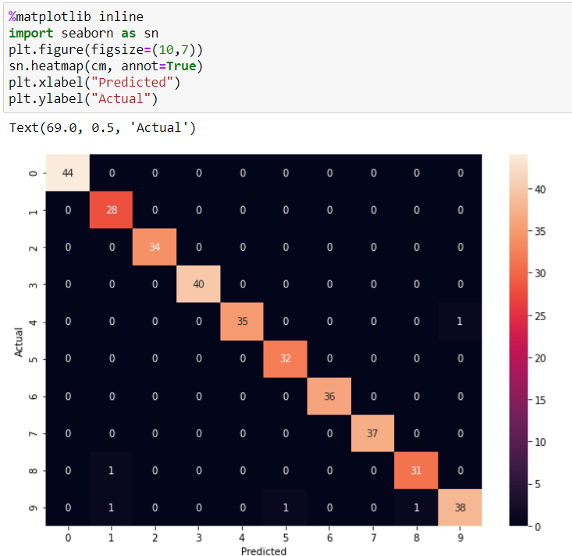

**Applications of Random Forest:**

There are several applications where a RF analysis can be applied. Some of the sectors where random forest can be applied are-

* Banking Sector:The banking sector consists of most users. There are many loyal customers and also fraud customers. To determine whether the customer is a [loyal or fraud](https://www.newgenapps.com/blogs/applications-artificial-intelligence-machine-learning-in-banking-finance/), Random Forest analysis comes in. With the help of a random forest algorithm in machine learning, we can easily determine whether the customer is fraud or loyal. A system uses a set of a random algorithm which identifies the fraud transactions by a series of the pattern.
* Medicines:Medicines needs a complex combination of specific chemicals. Thus, to identify the great combination in the medicines, Random Forest can be used. With the help of machine learning algorithm, it has become easier to detect and predict the drug sensitivity of a medicine. Also, it helps to identify the patient’s disease by analysing the patient’s medical record.
* Stock Market:Machine learning also plays role in the stock market analysis. When we want to know the behaviour of the stock market, with the help of Random Forest algorithm, the behaviour of the stock market can be analysed. Also, it can show the expected loss or profit which can be produced while purchasing a particular stock.
* E-Commerce:When we find it difficult to [recommend or suggest](https://www.newgenapps.com/blogs/what-is-recommendation-engine-uses-personalization/) what type of products the customer should see. This is where we can use a random forest algorithm. Using a machine learning system, we can suggest the products which will be more likely for a customer. Using a certain pattern and following the product’s interest of a customer, we can suggest similar products to your customers.

**PRINCIPAL COMPONENT ANALYSIS(PCA)**

**INTRODUCTION:**  
  
PCA is used in exploratory data analysis and for making predictive models. It is commonly used for dimensionality reduction by projecting each data point onto only the first few principal components to obtain lower-dimensional data while preserving as much of the data's variation as possible.   
  
PCA performs dimensionality reduction, which can reduce the number of features for the Random Forest to process, so PCA might help speed up the training of your Random Forest model.  
  
Reducing the number of variables of a data set naturally comes at the expense of accuracy, but the trick in dimensionality reduction is to trade a little accuracy for simplicity. Because smaller data sets are easier to explore and visualize and make analyzing data much easier and faster for machine learning algorithms without extraneous variables to process.  
  
So to sum up, the idea of PCA is simple — reduce the number of variables of a data set, while preserving as much information as possible.

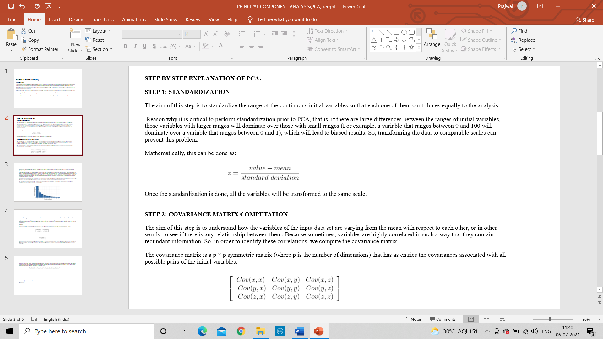**STEP BY STEP EXPLANATION OF PCA:  
  
STEP 1: STANDARDIZATION**  
  
The aim of this step is to standardize the range of the continuous initial variables so that each one of them contributes equally to the analysis.  
  
 Reason why it is critical to perform standardization prior to PCA, that is, if there are large differences between the ranges of initial variables, those variables with larger ranges will dominate over those with small ranges (For example, a variable that ranges between 0 and 100 will dominate over a variable that ranges between 0 and 1), which will lead to biased results. So, transforming the data to comparable scales can prevent this problem.  
  
Mathematically, this can be done as:

Once the standardization is done, all the variables will be transformed to the same scale.

**STEP 2: COVARIANCE MATRIX COMPUTATION**  
  
The aim of this step is to understand how the variables of the input data set are varying from the mean with respect to each other, or in other words, to see if there is any relationship between them. Because sometimes, variables are highly correlated in such a way that they contain redundant information. So, in order to identify these correlations, we compute the covariance matrix.  
  
The covariance matrix is a p × p symmetric matrix (where p is the number of dimensions) that has as entries the covariances associated with all possible pairs of the initial variables.

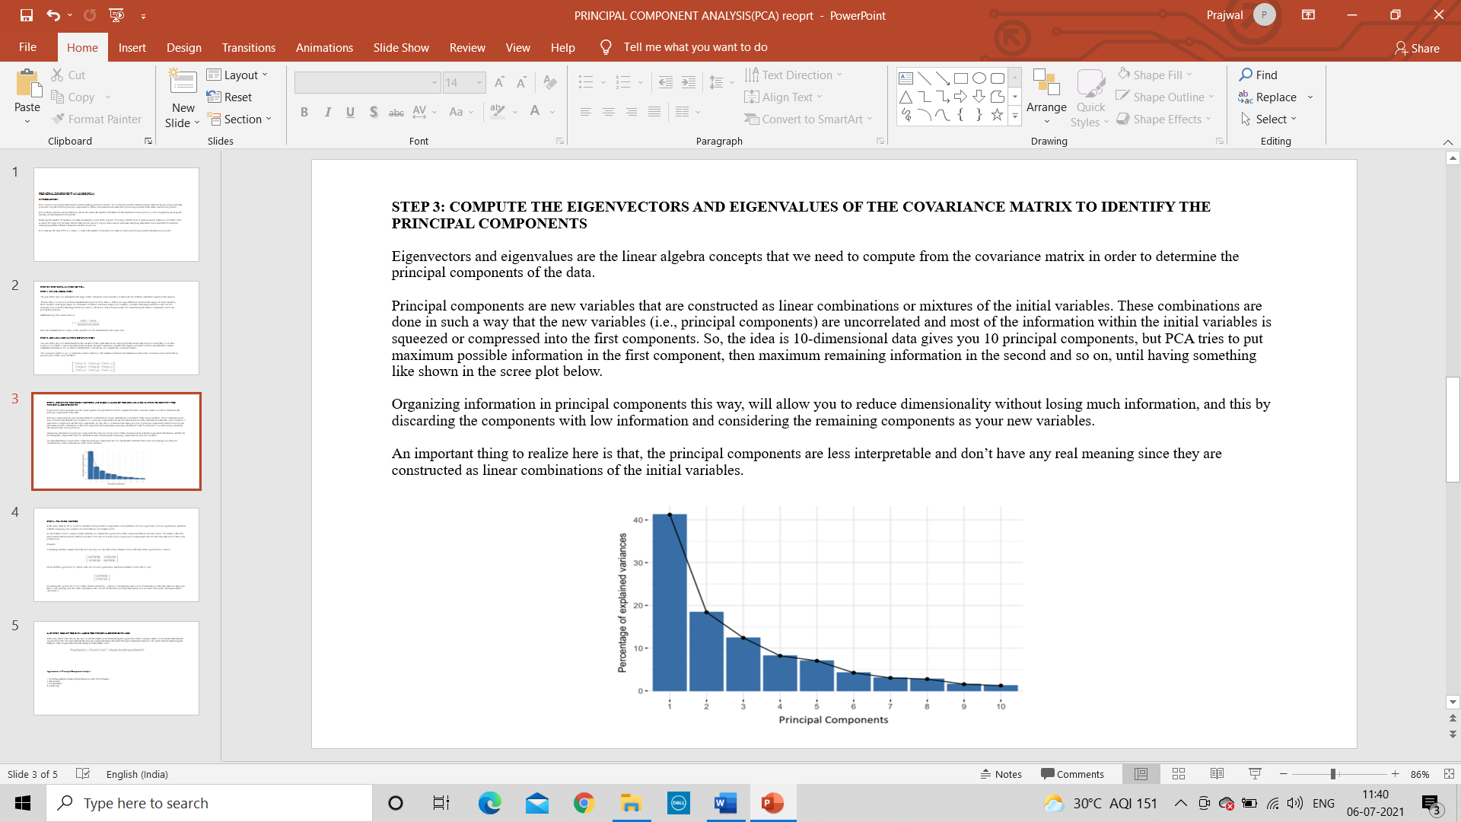**STEP 3: COMPUTE THE EIGENVECTORS AND EIGENVALUES OF THE COVARIANCE MATRIX TO IDENTIFY THE PRINCIPAL COMPONENTS**  
Eigenvectors and eigenvalues are the linear algebra concepts that we need to compute from the covariance matrix in order to determine the principal components of the data.  
  
Principal components are new variables that are constructed as linear combinations or mixtures of the initial variables. These combinations are done in such a way that the new variables (i.e., principal components) are uncorrelated and most of the information within the initial variables is squeezed or compressed into the first components. So, the idea is 10-dimensional data gives you 10 principal components, but PCA tries to put maximum possible information in the first component, then maximum remaining information in the second and so on, until having something like shown in the scree plot below.  
  
Organizing information in principal components this way, will allow you to reduce dimensionality without losing much information, and this by discarding the components with low information and considering the remaining components as your new variables.  
  
An important thing to realize here is that, the principal components are less interpretable and don’t have any real meaning since they are constructed as linear combinations of the initial variables.

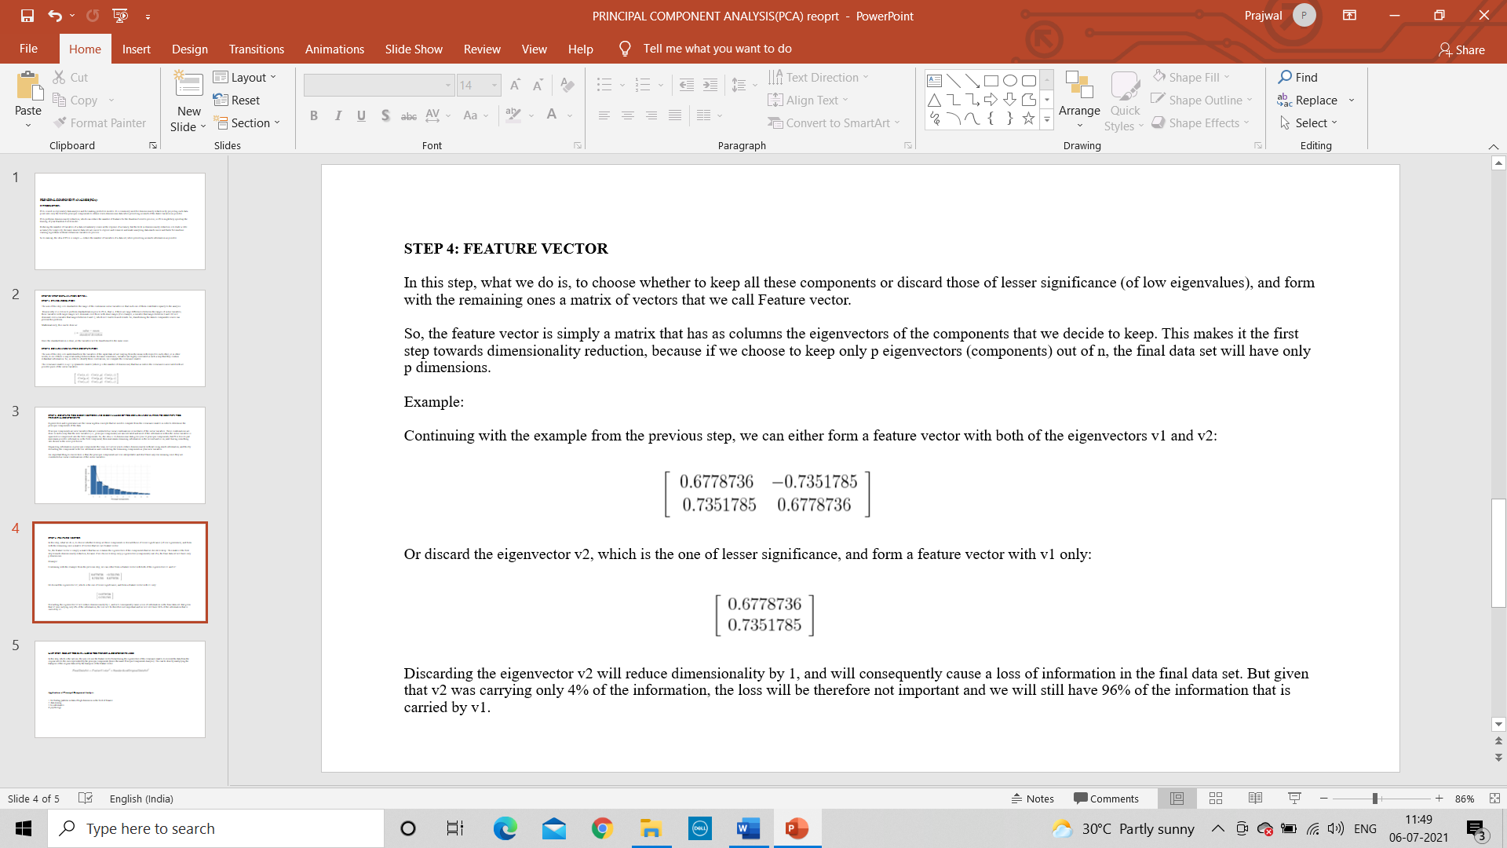**STEP 4: FEATURE VECTOR**  
  
In this step, what we do is, to choose whether to keep all these components or discard those of lesser significance (of low eigenvalues), and form with the remaining ones a matrix of vectors that we call Feature vector.  
  
So, the feature vector is simply a matrix that has as columns the eigenvectors of the components that we decide to keep. This makes it the first step towards dimensionality reduction, because if we choose to keep only p eigenvectors (components) out of n, the final data set will have only p dimensions.  
  
Example:  
  
Continuing with the example from the previous step, we can either form a feature vector with both of the eigenvectors v1 and v2:

Or discard the eigenvector v2, which is the one of lesser significance, and form a feature vector with v1 only:

Discarding the eigenvector v2 will reduce dimensionality by 1, and will consequently cause a loss of information in the final data set. But given that v2 was carrying only 4% of the information, the loss will be therefore not important and we will still have 96% of the information that is carried by v1.

**LAST STEP: RECAST THE DATA ALONG THE PRINCIPAL COMPONENTS AXES**  
In this step, which is the last one, the aim is to use the feature vector formed using the eigenvectors of the covariance matrix, to reorient the data from the original axes to the ones represented by the principal components (hence the name Principal Components Analysis). This can be done by multiplying the transpose of the original data set by the transpose of the feature vector.

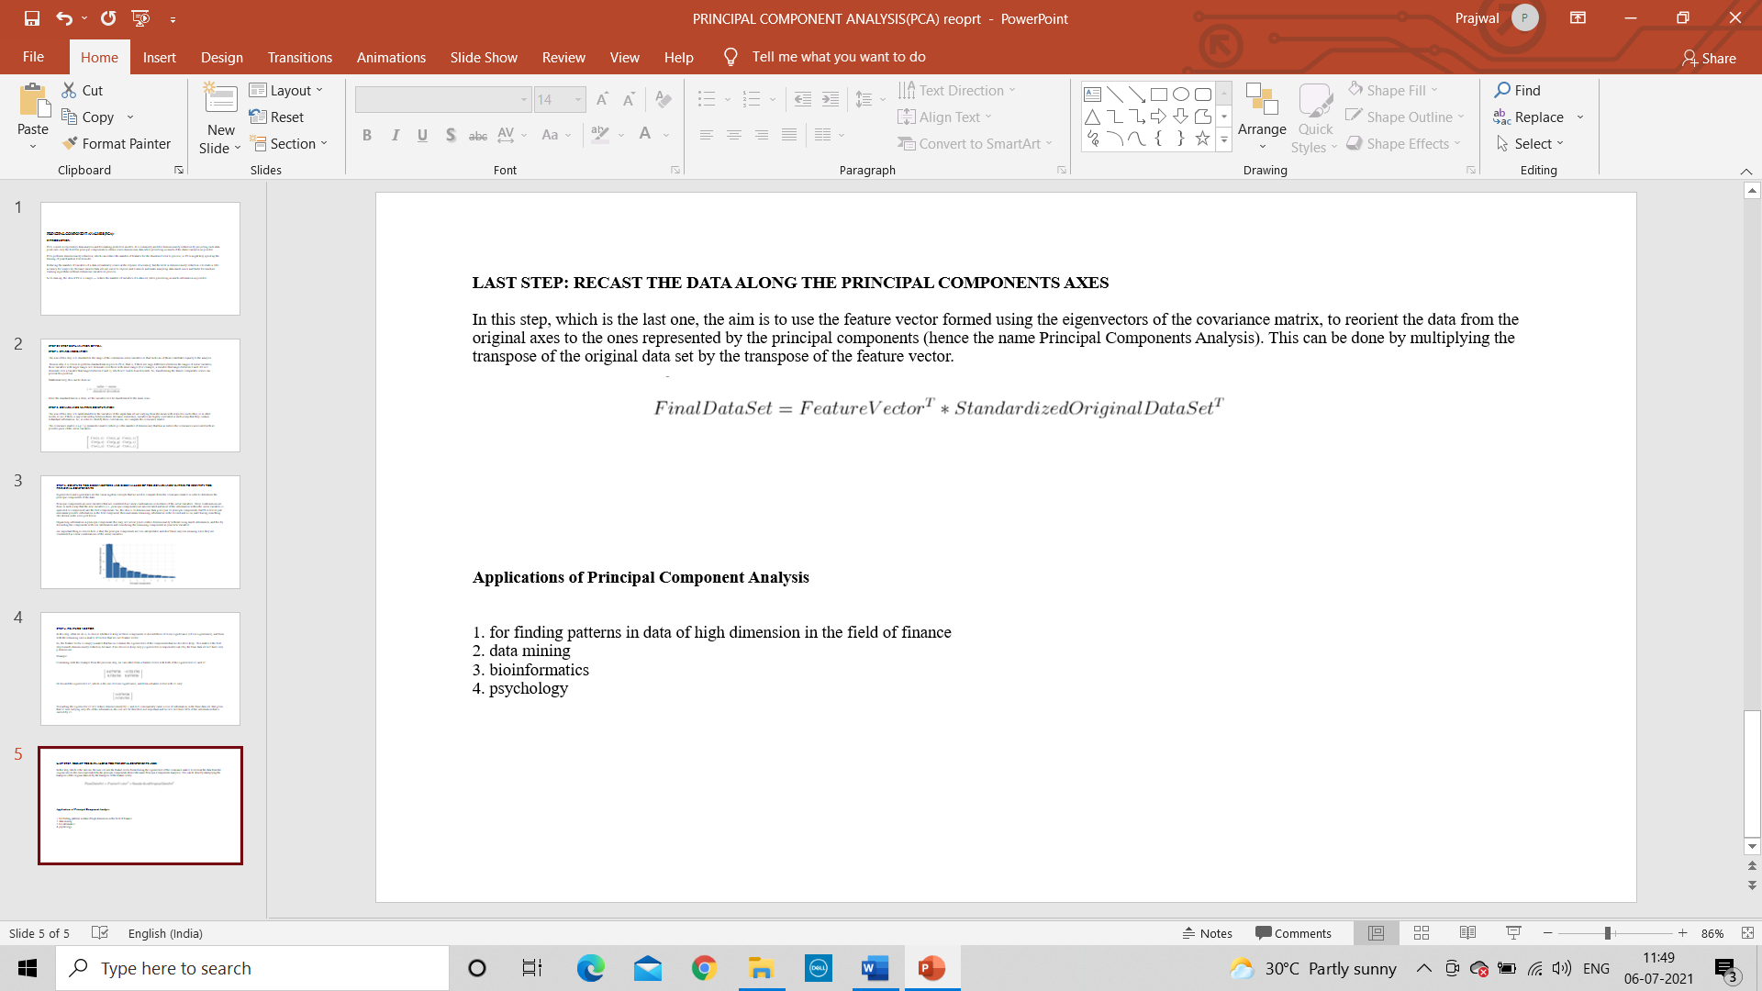

**Applications of Principal Component Analysis**  
  
  
1. for finding patterns in data of high dimension in the field of finance  
2. data mining  
3. bioinformatics  
4. psychology

**3.SOFTWARE LIBRARIES**

# 1.Introduction to Python

[Python](https://www.geeksforgeeks.org/python-programming-language/) is a widely used general-purpose, high level programming language. It was created by Guido van Rossum in 1991 and further developed by the Python Software Foundation. It was designed with an emphasis on code readability, and its syntax allows programmers to express their concepts in fewer lines of code.

Python is a programming language that lets you work quickly and integrate systems more efficiently.There are two major Python versions: **Python 2** and **Python 3**.

# 2.Scikit-learn

Scikit-learn provides a range of supervised and unsupervised learning algorithms via a consistent interface in Python.It is licensed under a permissive simplified BSD license and is distributed under many Linux distributions, encouraging academic and commercial use.The library is built upon the SciPy (Scientific Python) that must be installed before you can use scikit-learn.

Scikit-learn (formerly scikits.learn and also known as sklearn) is a free software machine learning library for the Python programming language.[3] It features various classification, regression and clustering algorithms including support vector machines, random forests, gradient boosting, k-means and DBSCAN, and is designed to interoperate with the Python numerical and scientific libraries NumPy and SciPy.

Scikit-learn is largely written in Python, and uses numpy extensively for highperformance linear algebra and array operations. Furthermore, some core algorithms are written in Cython to improve performance. Support vector machines are implemented by a Cython wrapper around LIBSVM;logistic regression and linear support vector machines by a similar wrapper around LIBLINEAR. In such cases, extending these methods with Python may not be possible. Scikit-learn integrates well with many other Python libraries, such as matplotlib and plotly for plotting, numpy for array vectorization, pandas data frames, scipy, and many more.

# Pandas

Pandas is mainly used for data analysis. Pandas allows importing data from various file formats such as comma-separated values, JSON, SQL, Microsoft Excel [6]. Pandas allows various data manipulation operations such as merging [7], reshaping [8], selecting [9], as well as data cleaning, and data wrangling features.

When you want to use Pandas for data analysis, you'll usually use it in one of three different ways:Convert a Python's list, dictionary or Numpy array to a Pandas data frame.Open a local file using Pandas, usually a CSV file, but could also be a delimited text file (like TSV),Excel, etc.

# NumPy

NumPy is a python library used for working with arrays.It also has functions for working in domain of linear algebra, fourier transform, and matrices.NumPy was created in 2005 by Travis Oliphant. It is an open source project and you can use it freely.NumPy stands for Numerical Python.In Python we have lists that serve the purpose of arrays, but they are slow to process.

# 5.Matplotlib

Matplotlib is a plotting library for the Python programming language and its numerical mathematics extension NumPy. It provides an object-oriented API for embedding plots into applications using general-purpose GUI toolkits like Tkinter, wxPython, Qt, or GGT.

Matplotlib was originally written by John D. Hunter. Since then it has an active development community and is distributed under a BSD-style license. Michael Droettboom was nominated as matplotlib's lead developer shortly before John Hunter's death in August 2012and was further joined by Thomas Caswell.

Matplotlib 2.0.x supports Python versions 2.7 through 3.10. Python 3 support started with Matplotlib 1.2. Matplotlib 1.4 is the last version to support Python 2.6 Matplotlib has pledged not to support Python 2 past 2020 by signing the Python 3 Statement.

**6.Seaborn**

Seaborn is a Python data visualization library based on [matplotlib.](https://matplotlib.org/) It provides a high-level interface for drawing attractive and informative statistical graphics .Seaborn aims to make visualization a central part of exploring and understanding data. Its dataset-oriented plotting functions operate on dataframes and arrays containing whole datasets and internally perform the necessary semantic mapping and statistical aggregation to produce informative plots.

Seaborn helps you explore and understand your data. Its plotting functions operate on dataframes and arrays containing whole datasets and internally perform the necessary semantic mapping and statistical aggregation to produce informative plots

**ALGORITHM**

**Multiple Regression Model**

#1 Import libraries :

Pandas : Data Processing numpy : linear algebra

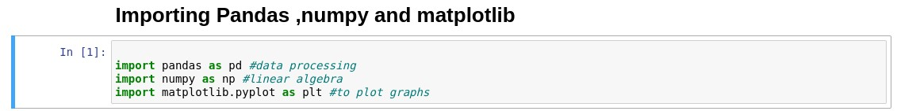Matplotlib : Visualisation i.e Plotting Graph

#2 Importing the Data Set.

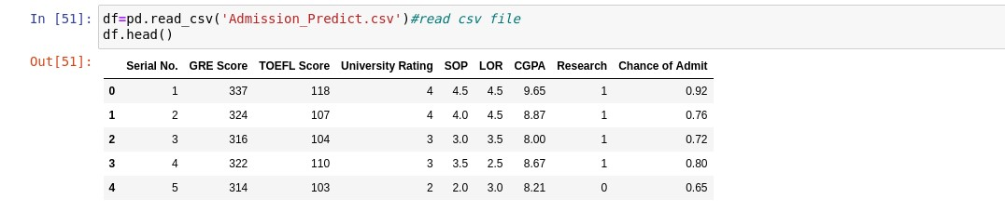

#3 Checking Data types of and if any entry null or empty.

Avoiding the Dummy Variable Trap.

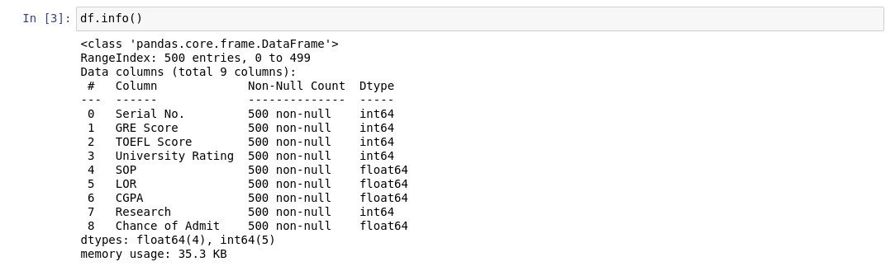

#4 Taking Columns in X and Y variable.



#5 Splitting the Data set into Training Set and Test Set.





#6 Fitting Multiple Linear Regression to the Training set



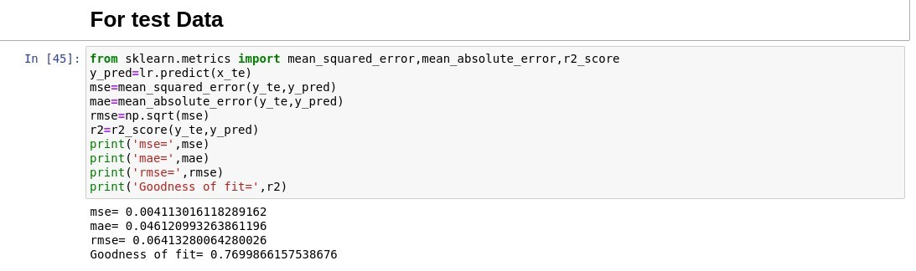#7 Predicting the Test set results.

#8 Predicting the Test set results.

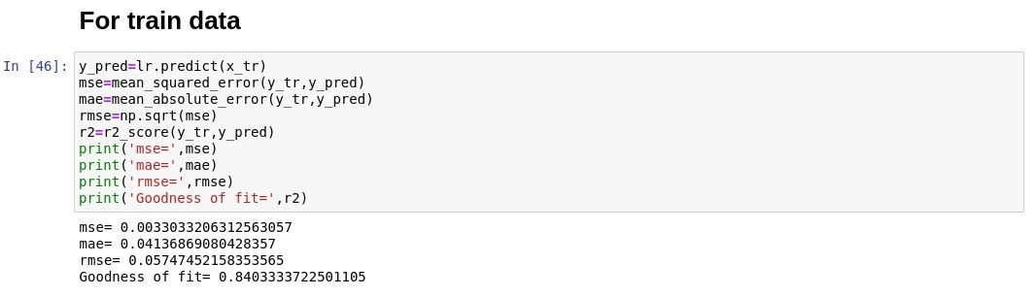

#9 Ploting graphs for visualization:



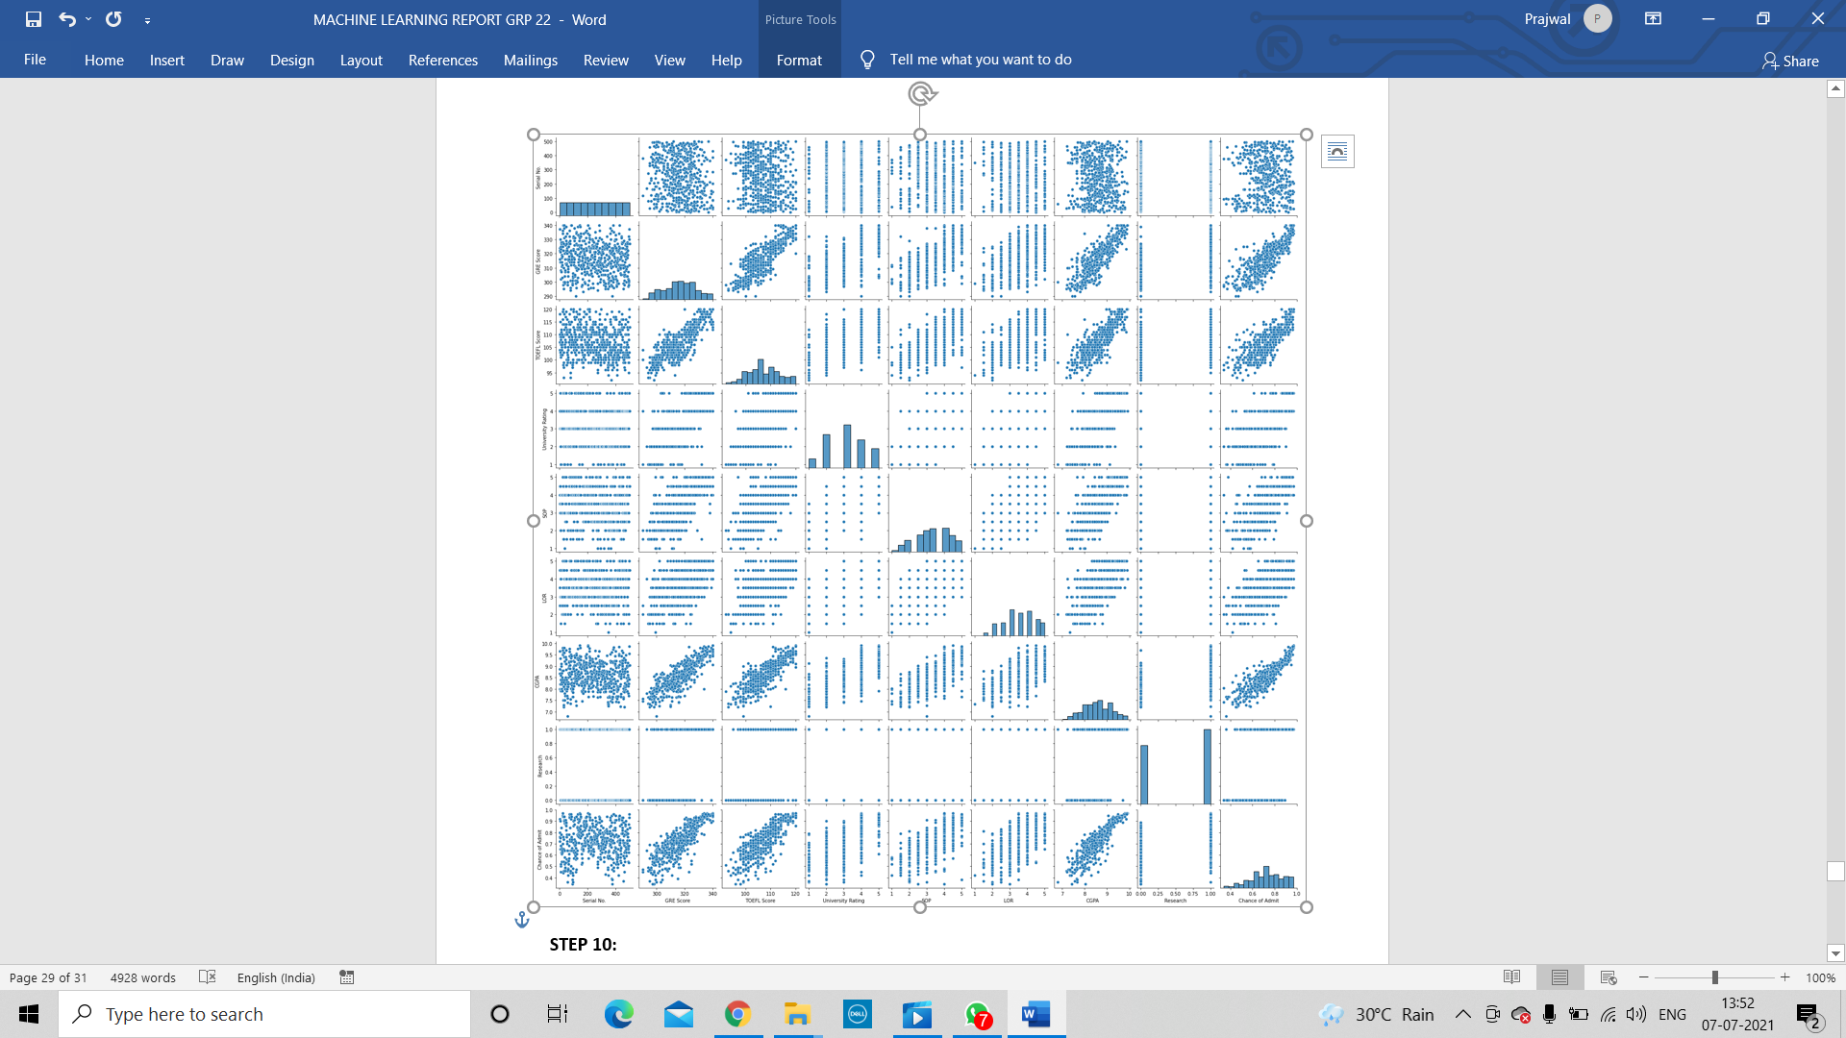

#10



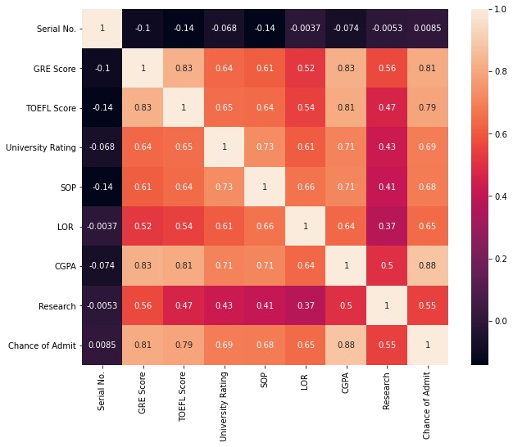

**Multiple Linear Regression model using Principal Component Analysis Algorithm:**

Step1) First we import the relevant libraries like pandas, numpy, sklearn, matplotlib, seaborn to our Jupyter notebook.

Step 2) Then we import the dataset (in our case, Admission_predict_ver1.csv).

Step 3) Allocate the features and the target to separate dataframes.

Step 4) Check the features and drop irrelevant features (serial_no).

Step 5). Standardize the features in training set.

Step 6) Perform Dimensionality Reduction using Principal Component Analysis on the training set.

Step 7). Divide the dataset into training set and testing set

Step 8) Plot the PCA data.

Step 9) Train the model using multiple linear regression.

Step 10) Test the model using the relevant evaluation metrics like R2_Score, RMSE, MAE.

Step 11) Try improving the R2_Score by performing standardization and various dimensionality reduction techniques.

Step 12) Plot the data.

**Random Forest Regression Model**

#1 Importing Python Libraries



#2 Importing the dataset and printing



#3 Checking if the data entry is null or empty and also the data type of the entered data**.** Avoiding the Dummy Variable Trap.



#4 Taking Columns in X and Y variable.



#5 Splitting our dataset into training set and test set



#6 Creating a Random Forest Regression model and fitting it to the training data



#7 Predicting for the test result

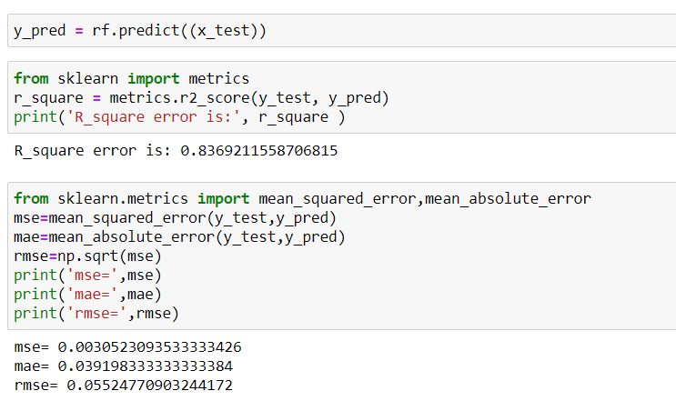

#8 Visualizing the Random Forest Regression model accuracy



**RANDOM FOREST USING PCA MODEL**

#1 Importing important libraries used for the model.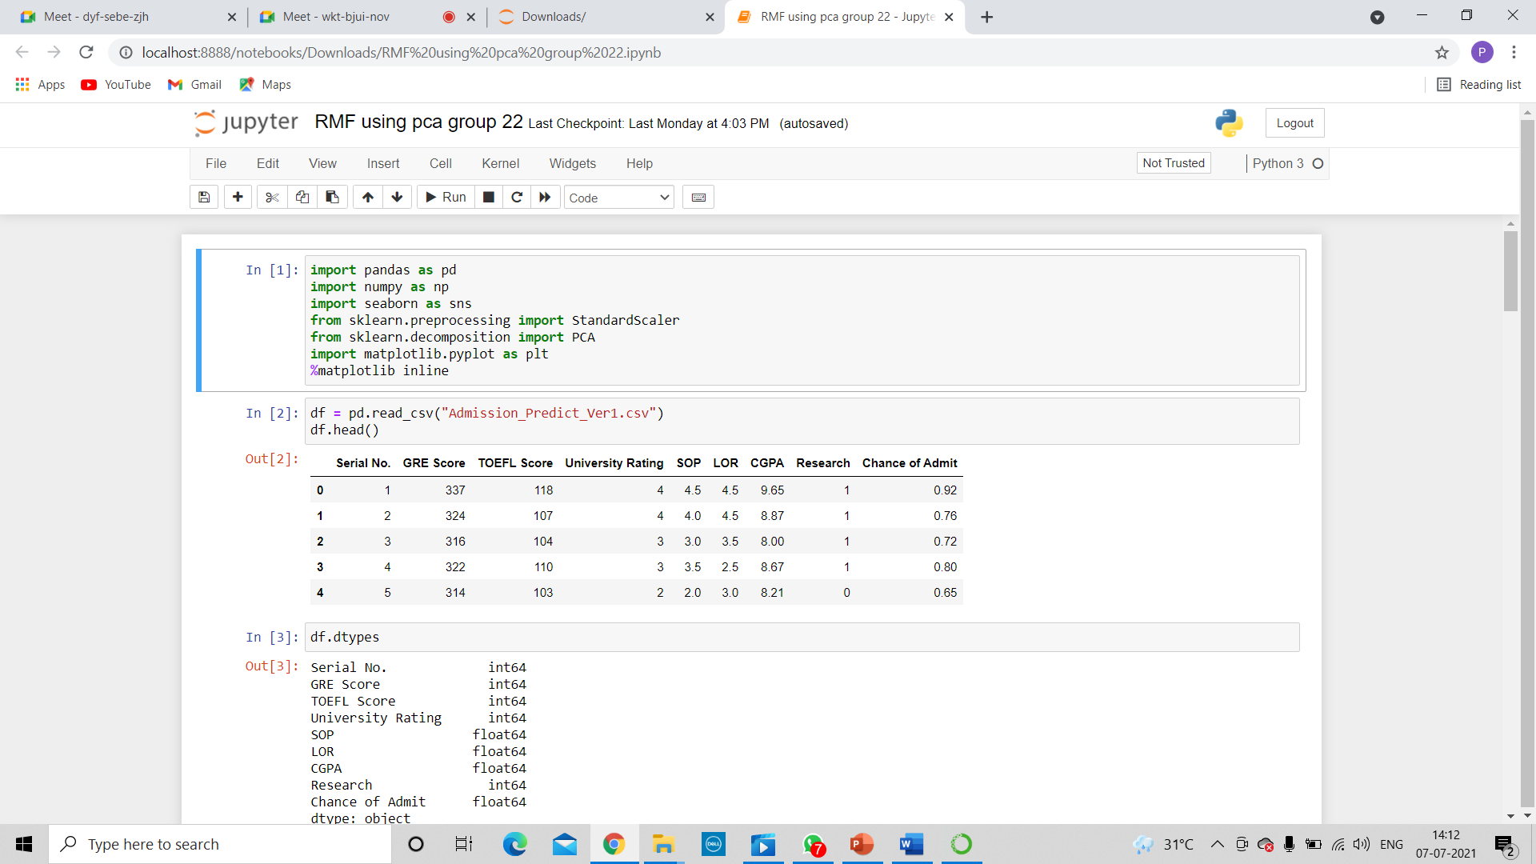

#2 Reading the given data set and loading into pandas data frame.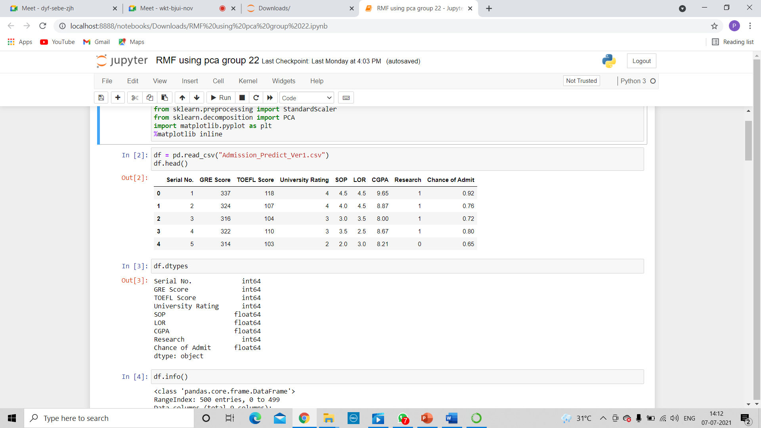

#3 checking data type and if it has any null values.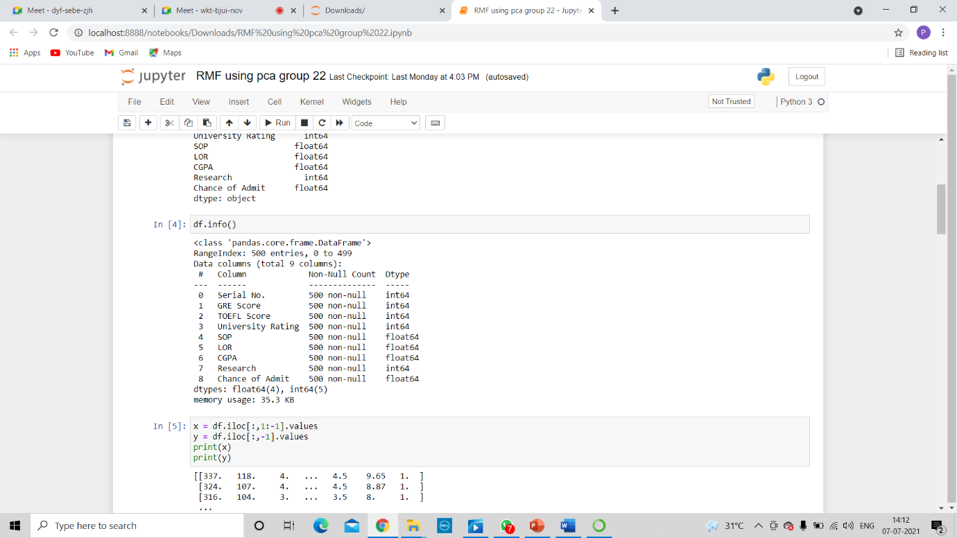



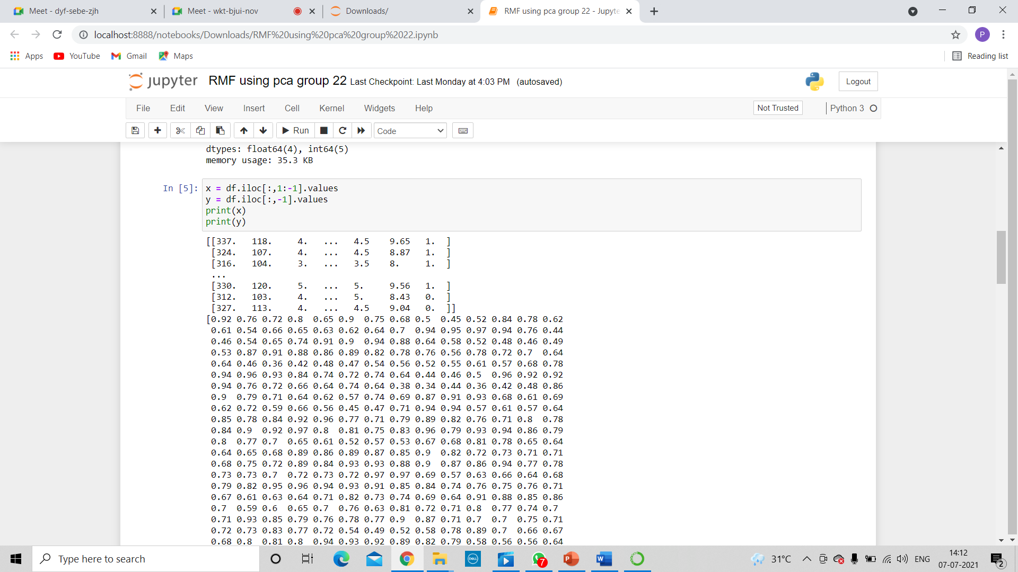#4 separating out the features.

#5 Visulazing the distribution of the data for every feature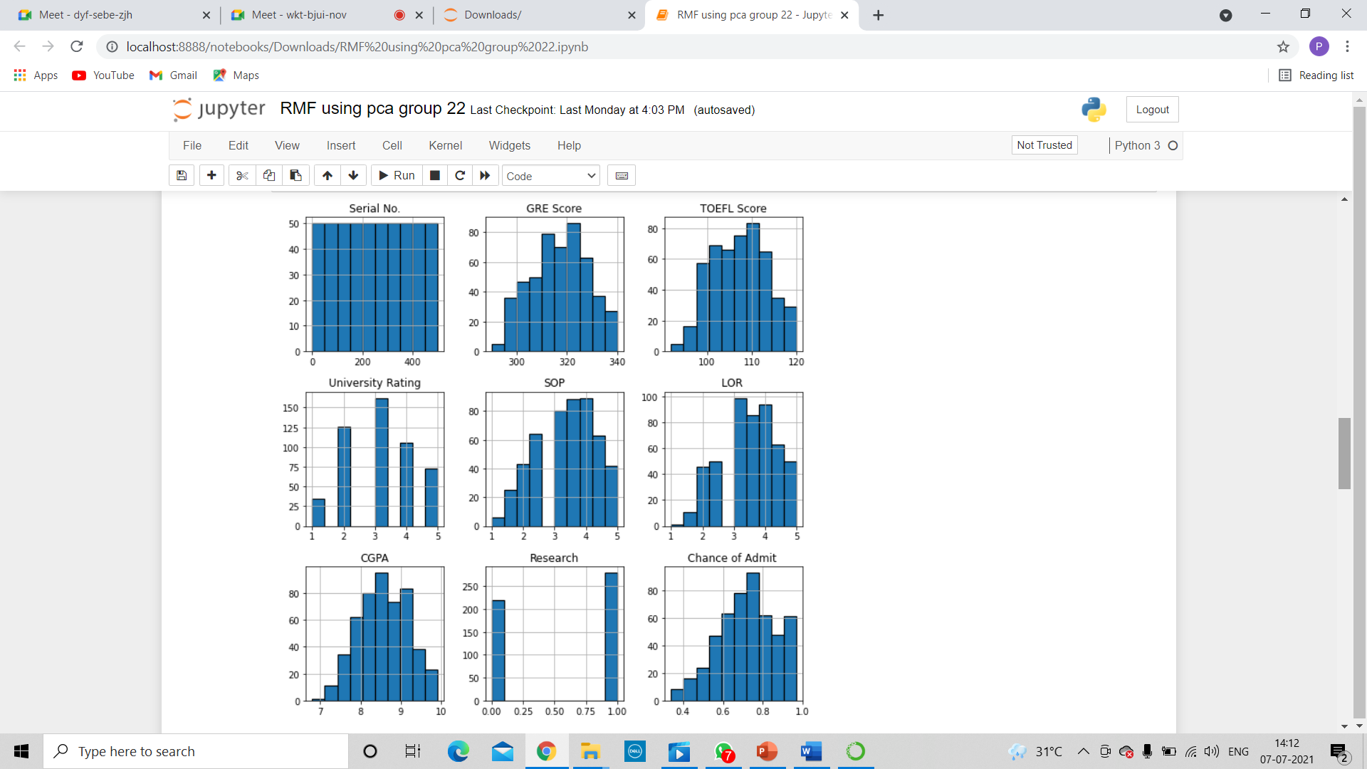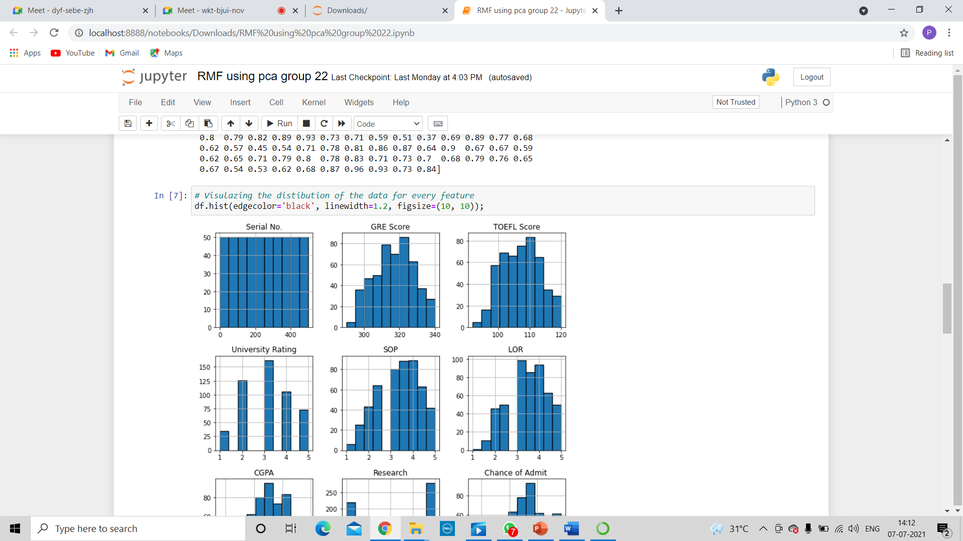

#6 Splitting the dataset into training and testing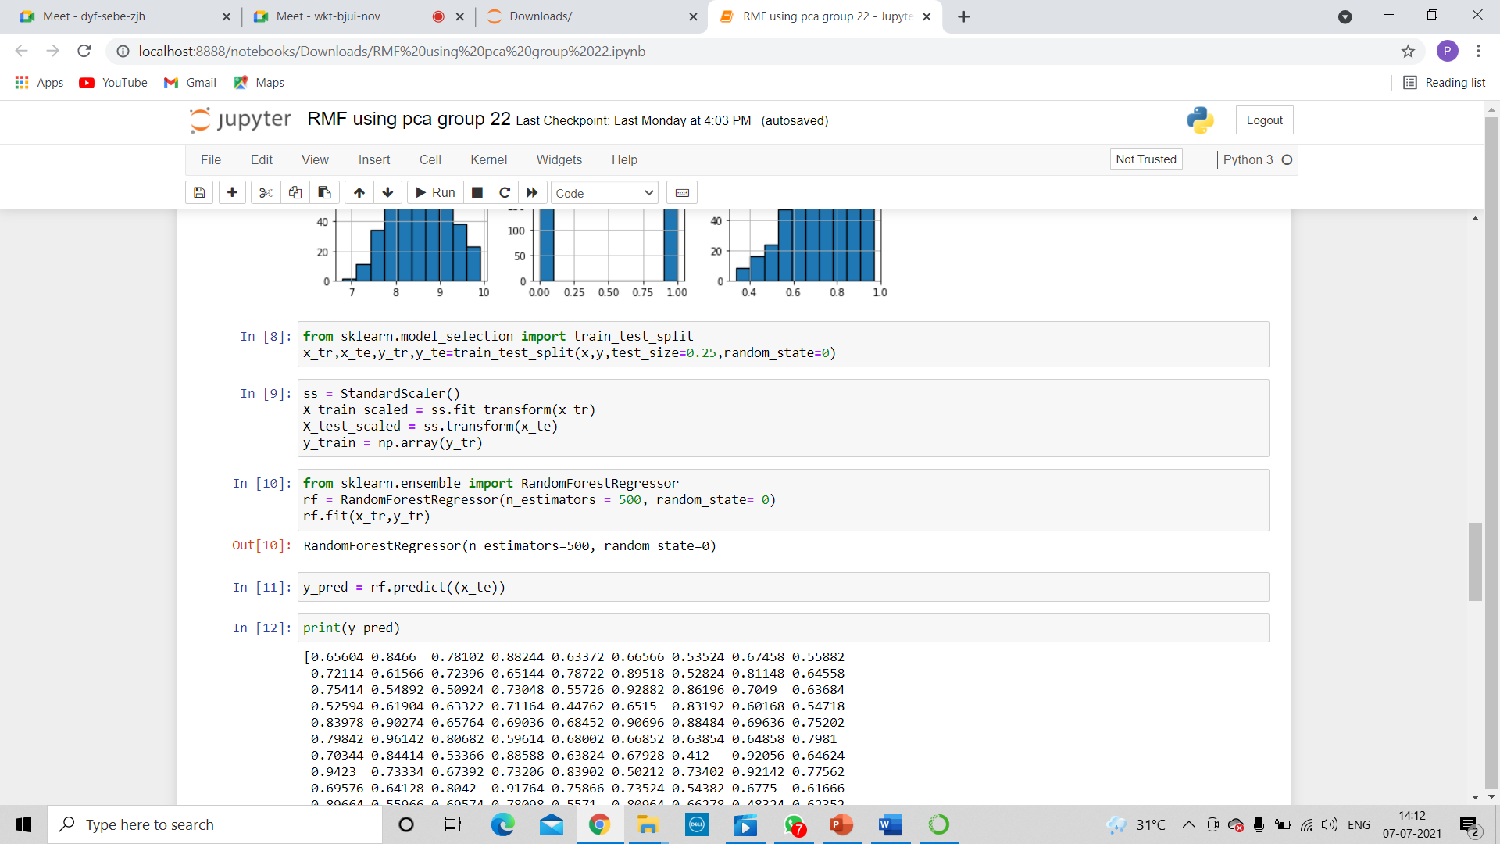

#7 scale the data

Before modeling, we need to “center” and “standardize” our data by scaling. We scale to control for the fact that different variables are measured on different scales.

#8 Building the random forest Regression Model

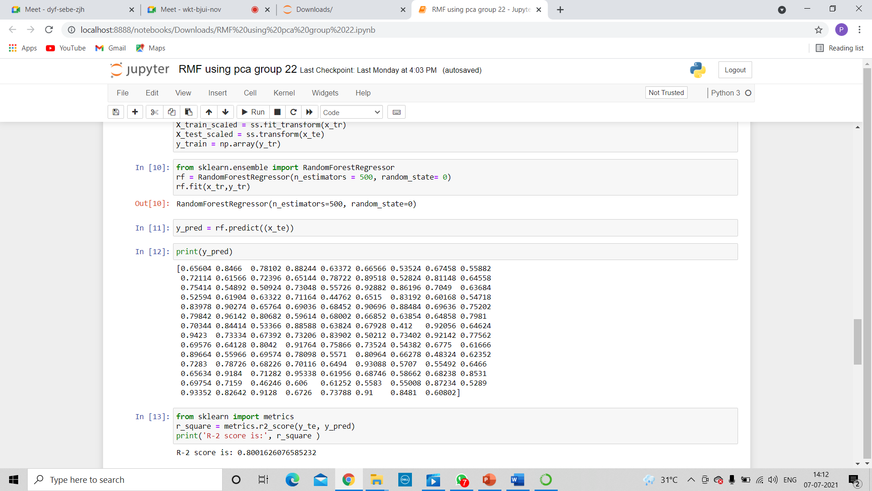The parameter n_estimators creates n number of trees in your random forest, where n is the number you pass in.

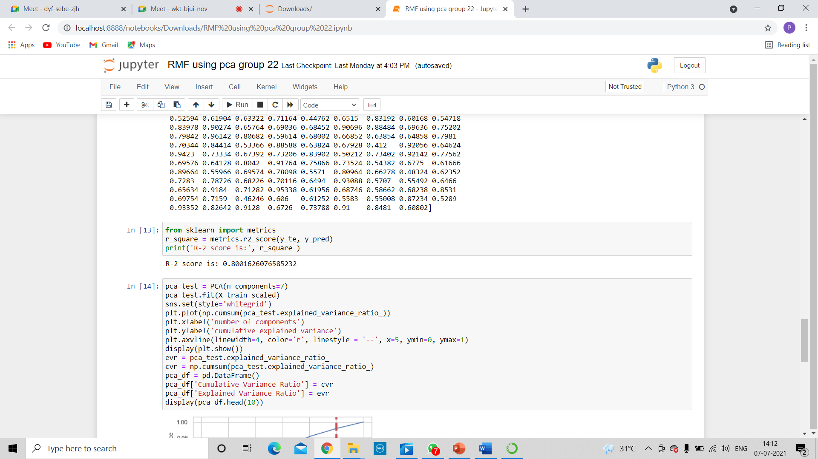#9 evaluating the model

#10 plotting the graph of explained and cumulative variance ratio to get an idea about how much data should be cut performing pca so there would be minimal loss of data by using the graph.

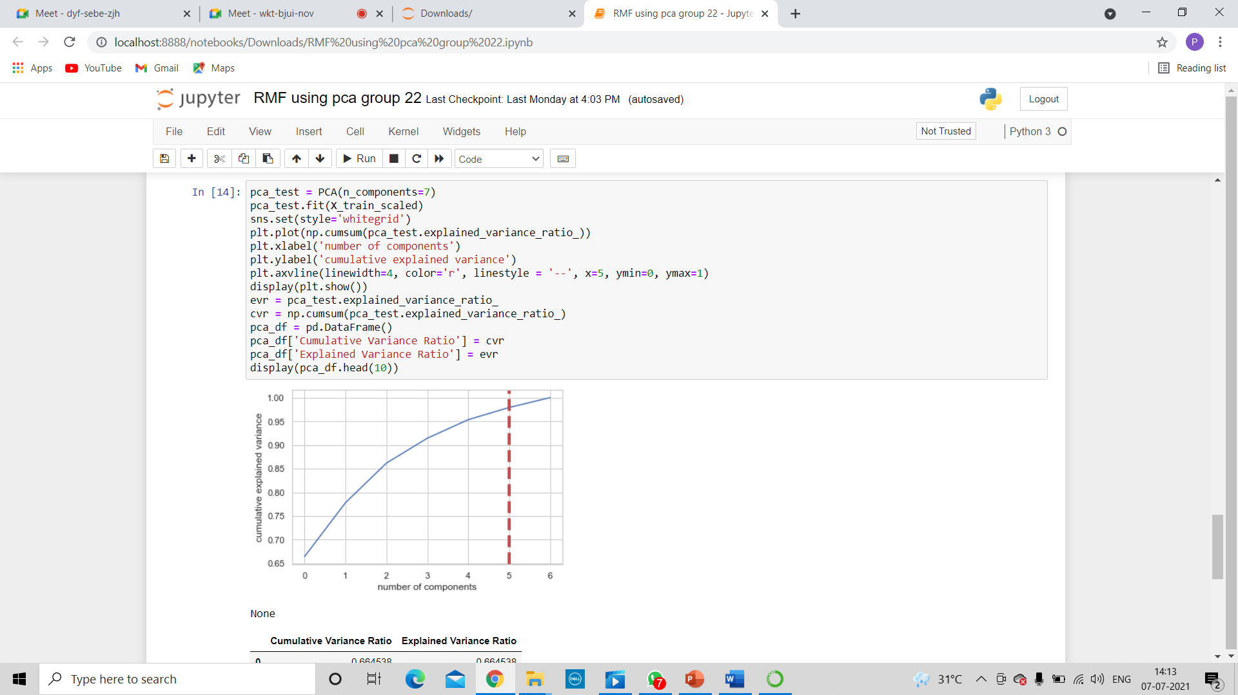graph shows that after more than 5 components, we don’t gain very much variation in variance

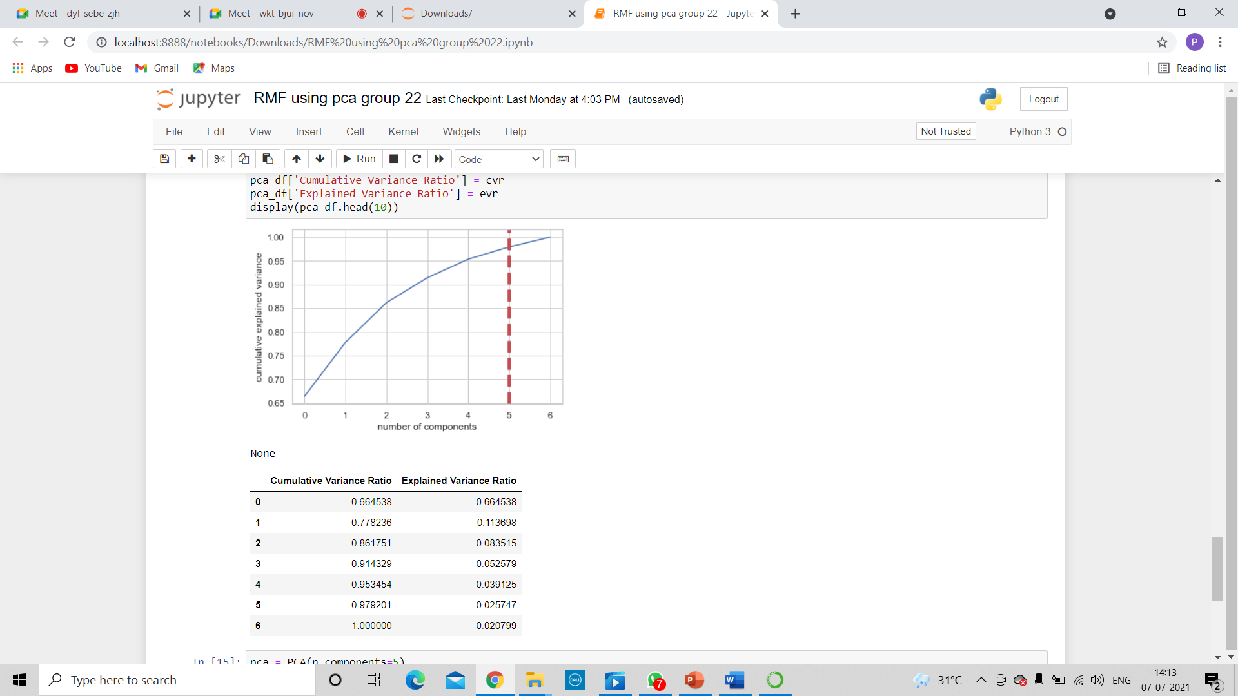



#11 Determining principal components and then using random forest in it to get the random forest score using pca .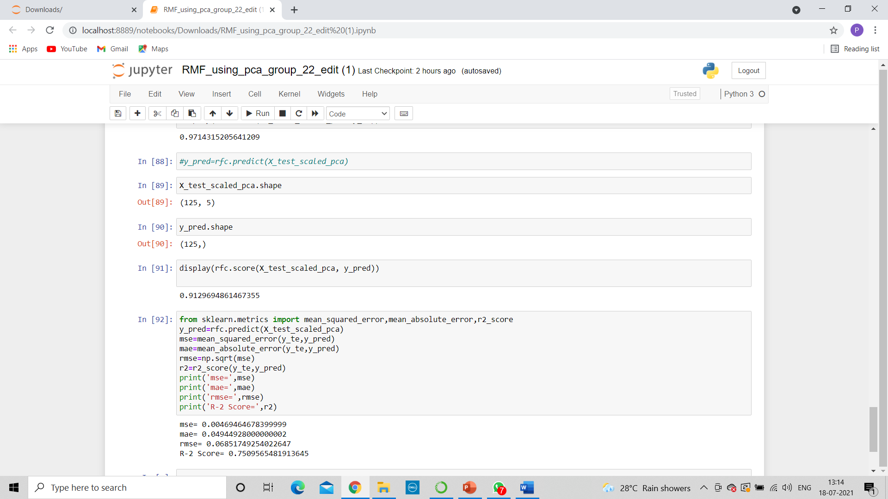

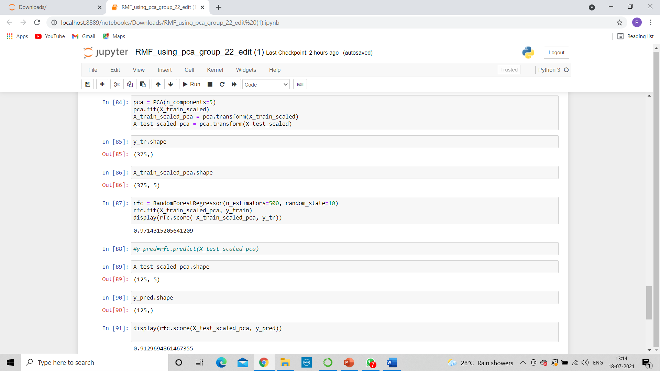



**4. CONCLUSION**

The subject of this project was to determine if the variables contribute to the admission of student to Master’s degree program with the help of prediction models. The results of this examination appear to indicate that it greatly contributes to the response variable ‘Chance of Admit’. Higher the GRE, TOEFL, score then higher the admit chances.

The model predicts 84% accuracy with multiple linear regression , 72% accuracy using multiple linear regression using PCA, 83% accuracy with random forest model and 90% accuracy with Random Forest model using PCA and can be used for predicting the admit chances based on the above factors. This model will be helpful for the universities to predict the admission and ease their process of selection and timelines.

As part of the hypothesis, the model proved that admission to Master’s degree program is dependent on GRE, TOEFL and other scores.

The results observed are that the R2_Score is high for Random Forest using PCA model while multiple regression model performed moderately. This implies using Random Forest, we can predict better whether a student gets admission or not.